  CORPORATE AUTHORITY  Registrar of Companies and Partnerships | STATE OF ISRAEL  MINISTRY OF JUSTICE –  CORPORATES AUTHORITY  Registrar of Companies and Partnerships | 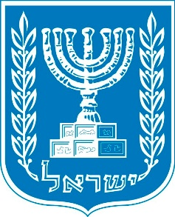

Company Name Change Certificate
We here be certify that the company:
COMPANY NAME
No. _____________
Has changed its name and from now on will be called:
COMPANY NAME

Issued at __________ on:  בחר פריט. / בחר פריט. / ___  בחר פריט. בחר פריט. ___  Executed by _____________, lawyer. |   MINISTRY OF JUSTICE – CORPORATE AUTHORITY  _____________. lawyer.  Registrar of Companies and Partnerships  Head of Corporates' Authority

